**SECURE E-VOTING USING QR-CODE**

**Abstract:**

Voting system is very essential for electing leaders to lead our nation. Nowadays, e-voting is developed to make easy for citizens of India to vote through online without visiting polling booth. E-voting would be the security risk that can be potentially undermine the election process. It may susceptible to a range of threats such as hacking by domestic and foreign saboteurs. In order to address this issues , our proposed system uses QR code for safe voting

**Introduction**

In every democracy, the security of an election is a matter of national security. The computer security field has for a decade studied the possibilities of electronic voting systems , with the goal of minimizing the cost of having a national election, while fulfilling and increasing the security conditions of an election. From the dawn of democratically electing candidates, the voting system has been based on pen and paper. Replacing the traditional pen and paper scheme with a new election system is critical to limit fraud and having the voting process traceable and verifiable. Electronic voting machines have been viewed as flawed, by the security community, primarily based on physical security concerns. Anyone with physical access to such machine can sabotage the machine, thereby affecting all votes cast on the aforementioned machine.

**Existing System**

Vulnerability to hacking

One of the main problems is that in most countries voting is anonymous. It's hard to find a way that people can vote online, without authentication (because anyone can only vote 1 time) and assure that the vote is not bound to an identity.Anonymity has multiple underlying problems that relate to preventing people from voting more than once. The latter is easy enough in theory: maintain a list of people who already voted, and prevent them from voting twice.

**Proposed System:**

Secured Login makes our application Secure and Safe.

QR OTP code generation replaces traditional Login format.

Database Encryption and Decryption to protect the data owner’s Privacy and File manager using **Base64 Crypto Algorithm.**

**IMPLEMENTATION MODULES**

**Modules**

**USER**

* + Visit Site
  + Apply Candidate
  + QR Scanning
  + QR Reading
  + Polling
  + Database cryptography

**ADMIN**

* + Manage Voter Details
  + Generate QR Coin
  + Manage Candidate details

**Module description**

**USER MODULES**

**Visit Site**

The user first visits the site where they have to cast the vote.

**Apply Candidate**

In this module, public users who are willing to apply for candidate can apply here by providing required details. All applied candidate can be elected as candidate. Admin only approve candidate.

**QR Scanning**

After the QR Coin is generated, the user can view the site only at the particular date and time and only at this time the user can view and access the site

and the user can scan QR .

**QR Reading**

In this project we can read our QR code by browsing and add QR image into our QR reader. We have alternative QR reading technology by using the scanner. Once we scan the QR and submit it into the QR reader the scanned image will be retrieved and the user can see the information provided in the decrypted QR. After scanned the QR and the information provided in the image will be decrypted.

**Polling**

After the QR is scanned, the user can poll votes. The user can view to whom they want to vote and poll accordingly and the voting details are viewed with database security using Encryption process. The voting process is now more secured.

**Database cryptography**

In this module, when all the votes are collected, they are stored in database after QR scanning. Each votes are scanned and stored in database after encryption so that authentication becomes even more secure. For this database security, Blockchain technology is used.

**ADMIN MODULES**

**Manage Voter Details**

In this module, the user can add voter list and the admin only can access voter details and can update the voter details as and when necessary.

**Generate QR Coin**

After adding the details, QR Coin is generated and distributed to the particular user. Only that particular user can view the details and at particular date and time. Only with that QR Coin only the user can cast votes.

**Manage Candidate details**

In this modules, all applied candidate details will be managed. Admin can approve only particular candidate. And Party symbols will be allocated by admin to approved candidates.

**SOFTWARE REQUIREMENTS**

Operating System : Windows 7

Front-End : HTML,CSS

Web Server : Apache

Back End : MySQL,PHP

**1 PHP:**

PHP: Hypertext Preprocessor (the name is a recursive acronym) is a widely used, general-purpose scripting language that was originally designed for web development to produce dynamic web pages. For this purpose, PHP code is embedded into the HTML source document and interpreted by a web server with a PHP processor module, which generates the web page document. Hypertext refers to files linked together using hyperlinks, such as HTML (Hypertext Markup Language) files. Preprocessing is executing instructions that modify the output. Below is a demonstration of the difference between HTML and PHP files.

**4.2 MY SQL:**

Not only is MySQL the world's most popular open source database, it's also become the database of choice for a new generation of applications built on the LAMP stack (Linux, Apache, MySQL, PHP / Perl / Python.) MySQL runs on more than 20 platforms including Linux, Windows, Mac OS, Solaris, HP-UX, IBM AIX, giving you the kind of flexibility that puts you in control.

**4.3 HTML:**

HTML, which stands for Hypertext Markup Language, is the predominant markup language for web pages. HTML is the basic building-blocks of webpage. HTML is written in the form of HTML elements consisting of tags, enclosed in angle brackets (like <html>), within the web page content. HTML tags normally come in pairs like <h1> and </h1>. The first tag in a pair is the start tag, the second tag is the end tag (they are also called opening tags and closing tags).

**DFD**

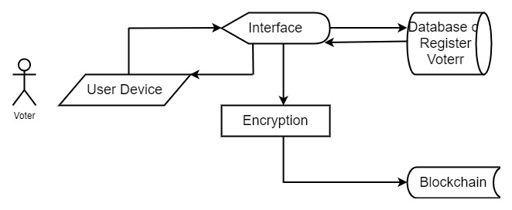

**Architecture:**

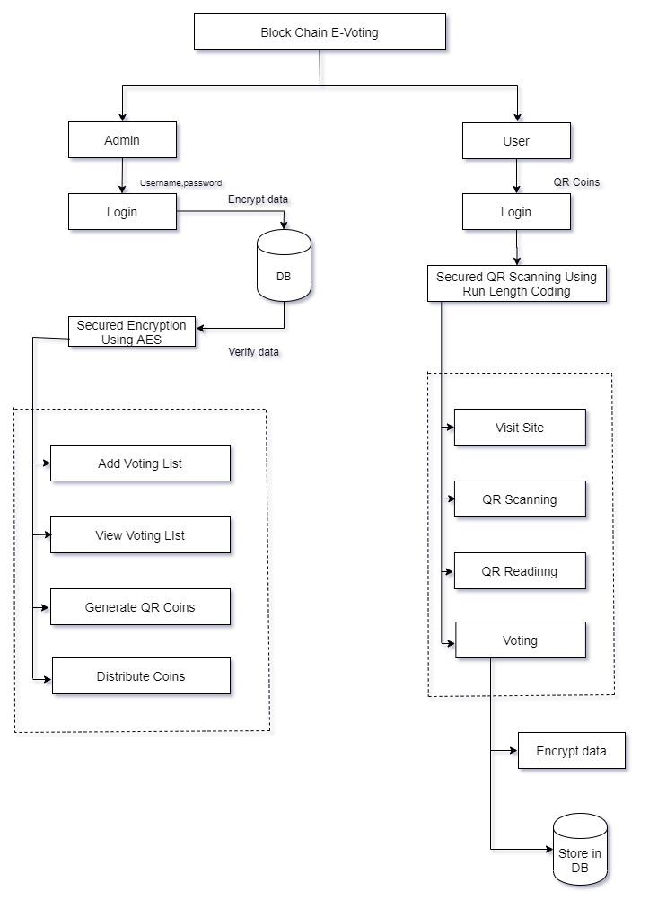

**Test Cases:**

Test cases are derived to ensure that all statements in the program have been executed at least once during testing and that all logical conditions have been executed. Using White-Box testing methods, the software engineer can drive test cases that

* Guarantee that logical decisions on their true and false sides.
* Exercise all logical decisions on their true and false sides.
* Execute all loops at their boundaries and within their operational bounds.
* Exercise internal data structure to assure their validity.
* The test case specification for system testing has to be submitted for review before system testing commences.

**Source Code**

**Home**

<!-- DEVELOPED BY VALAVAN -->

<!-- structure of php -->

<!Doctype html>

<head>

<title>WEB ROBO</title>

<link rel="stylesheet" href="https://maxcdn.bootstrapcdn.com/bootstrap/4.4.1/css/bootstrap.min.css">

<script src="https://ajax.googleapis.com/ajax/libs/jquery/3.4.1/jquery.min.js"></script>

<!-- Popper JS -->

<script src="https://cdnjs.cloudflare.com/ajax/libs/popper.js/1.16.0/umd/popper.min.js"></script>

<!-- Latest compiled JavaScript -->

<script src="https://maxcdn.bootstrapcdn.com/bootstrap/4.4.1/js/bootstrap.min.js"></script>

</head>

<body style="background:#dcd5bc">

<?php

include_once('auth.php');

include 'config/db_connection.php';

?>

<!-- wrapper starts-->

<div class="container">

<div class="row">

<div class="col-lg-12">

<div id="header">

<h1 style="background:midnightblue;color:white;font-size:26px;padding:30px;font-family:elephant"> Block Chain Enabled E-Voting </h1>

</div>

<div id="content" style="background:white;margin-top:-10px;margin-bottom:60px;height:500px">

<a href="candidate_application_form.php" class="btn" style="float:right;margin:20px;background:darkgreen;color:white;">Candidate Application</a>

<a href="admin/index.php" class="btn " style="float:right;margin:20px;background:maroon;color:white;">Admin Login</a>

</div>

<div style="height:50px;background:black">

</div>

</div>

<div id="footer">

</div>

</div>

</div>

<!-- wrapper ends-->

</body>

**Candidate application**

<!-- DEVELOPED BY VALAVAN -->

<!-- structure of php -->

<!Doctype html>

<head>

<title>WEB ROBO</title>

<link rel="stylesheet" href="https://maxcdn.bootstrapcdn.com/bootstrap/4.4.1/css/bootstrap.min.css">

<script src="https://ajax.googleapis.com/ajax/libs/jquery/3.4.1/jquery.min.js"></script>

<!-- Popper JS -->

<script src="https://cdnjs.cloudflare.com/ajax/libs/popper.js/1.16.0/umd/popper.min.js"></script

<!-- Latest compiled JavaScript -->

<script src="https://maxcdn.bootstrapcdn.com/bootstrap/4.4.1/js/bootstrap.min.js"></script>

</head>

<body style="background:#dcd5bc">

<?php

include_once('auth.php');

include 'config/db_connection.php';

?>

<!-- wrapper starts-->

<div class="container" >

<div class="row" style="background:white;">

<div class="col-lg-12">

<div id="header">

<h1 style="background:midnightblue;color:white;font-size:26px;padding:30px;font-family:elephant"> Block Chain Enabled E-Voting </h1>

</div>

<div class="" style="margin-top:50px;padding:0px 20px">

<form>

<span style="margin-bottom:10px"><center><h1>Candidate Application</h1></center></span>

<div class="form-row">

<div class="form-group col-md-6">

<label for="inputEmail4">Name</label>

<input type="text" class="form-control" placeholder="Name">

</div>

<div class="form-group col-md-6">

<label for="inputPassword4">First Name</label>

<input type="firstname" class="form-control" placeholder="First Name">

</div>

</div>

<div class="form-row">

<div class="form-group col-md-4">

<label for="inputAddress">Age</label>

<input type="text" class="form-control" placeholder="Enter Your age">

</div>

<div class="form-group col-md-4">

<label for="inputAddress">DOB</label>

<input type="date" class="form-control" placeholder="Date of Birth">

</div>

<div class="form-group col-md-4">

<label for="inputState">Gender</label>

<select id="inputState" class="form-control">

<option selected>Choose...</option>

<option>Male</option>

<option>Female</option>

</select>

</div>

</div>

<div class="form-row">

<div class="form-group col-md-6">

<label for="inputAddress">Father Name/Mother Name/Husband Name</label>

<input type="text" class="form-control" id="inputAddress" placeholder="Enter Name">

</div>

<div class="form-group col-md-6">

<label for="inputAddress">Qualification</label>

<input type="text" class="form-control" placeholder="Qualification">

</div>

</div>

<div class="form-group">

<label for="inputAddress">Present Address</label>

<input type="text" class="form-control" id="inputAddress" placeholder="1234 Main St">

</div>

<div class="form-group">

<label for="inputAddress2">Permanent Address </label>

<input type="text" class="form-control" id="inputAddress2" placeholder="Apartment, studio, or floor">

</div>

<div class="form-row">

<div class="form-group col-md-6">

<label for="inputCity">City</label>

<input type="text" class="form-control" id="inputCity">

</div>

<div class="form-group col-md-4">

<label for="inputState">State</label>

<select id="inputState" class="form-control">

<option selected>Choose...</option>

<option>...</option>

</select>

</div>

<div class="form-group col-md-2">

<label for="inputZip">PinCode</label>

<input type="text" class="form-control">

</div>

</div>

<div class="custom-file" style="margin-bottom:20px">

<input type="file" class="custom-file-input" id="customFileLang" lang="es">

<label class="custom-file-label" for="customFileLang">upload your image</label>

</div>

<button type="submit" class="btnbtn-primary">Submit</button>

</form>

</div>

<br/>

<div style="height:50px;background:black">

</div>

</div>

<div id="footer">

</div>

</div>

</div>

<!-- wrapper ends-->

</body>

**Candidate detail**

<?phpob_start(); ?>

<!DOCTYPE html>

<html lang="en">

<head>

<meta charset="utf-8">

<meta name="viewport" content="width=device-width, initial-scale=1.0">

<meta name="description" content="">

<meta name="author" content="">

<title> QR Code Generation || Admin </title>

<link rel="shortcut icon" href="../images/favicon.ico" />

<!-- Bootstrap core CSS -->

<link href="assets/css/bootstrap.css" rel="stylesheet">

<link href="assets/css/mobile.css" rel="stylesheet">

<style>

#brand:hover{

color : #000000;

}

</style>

</head>

<body>

<?phpinclude_once("../config/db_connection.php"); ?>

<nav class="navbarnavbar-inverse navbar-fixed-top" role="navigation">

<div class="container" id="menu">

<div class="navbar-header">

<button type="button" class="navbar-toggle" id="collapse-btn" data-toggle="collapse" data-target=".navbar-ex1-collapse">

<span class="sr-only">Toggle navigation</span>

<span class="icon-bar"></span>

<span class="icon-bar"></span>

<span class="icon-bar"></span>

</button>

<a class="navbar-brand col-lg-12" id="brand" style="color:black;">

<span style="font-family:elephant">Block Chain Enabled E-Voting</span>

</a>

</div>

<div class="collapse navbar-collapse navbar-ex1-collapse">

<ul class="navnavbar-navnavbar-right admin-ul" id="collapse-ul">

<li class="text-center current"><a href="staff.php">Staff Detail</a></li>

<li class="text-center "><a href="quest_bank.php">Question Bank</a></li>

<li class="text-center"><a href="index.php"> Logout </a></li>

</ul>

</div><!-- /.navbar-collapse -->

</div><!-- /.container -->

</nav>

<div class="container">

<div class="row-fluid mtop120">

<div class="col-lg-12 ">

<div class="panel panel-default bg-white">

<div class="panel-heading hidden-xs">

<imgsrc="images/user.png" alt="">

Staff Detail

<span class="span-crumb pull-right mtop10">

</span>

</div>

<div class="col-lg-12 col-md-12 col-sm-12 col-xs-12 bg-white">

<!-- /.panel-heading -->

<div class="col-md-5 mtop20 pbot20">

<div class="row">

</div>

</div>

<div class="col-md-3 mtop20 pbot20">

</div>

**Candidate voter list**

<?phpob_start(); ?>

<!DOCTYPE html>

<html lang="en">

<head>

<meta charset="utf-8">

<meta name="viewport" content="width=device-width, initial-scale=1.0">

<meta name="description" content="">

<meta name="author" content="">

<link rel="stylesheet" href="https://cdnjs.cloudflare.com/ajax/libs/font-awesome/4.7.0/css/font-awesome.min.css">

<title> QR Code Generation || Admin </title>

<link rel="shortcut icon" href="../images/favicon.ico" />

<!-- Bootstrap core CSS -->

<link href="assets/css/bootstrap.css" rel="stylesheet">

<link href="assets/css/mobile.css" rel="stylesheet">

<style>

#brand:hover{

color : #000000;

}

</style>

<style>

body {font-family: Arial, Helvetica, sans-serif;}

* {box-sizing: border-box;}

.input-container {

display: -ms-flexbox; /* IE10 */

display: flex;

width: 100%;

margin-bottom: 15px;

}

.icon {

padding: 10px;

background: dodgerblue;

color: white;

min-width: 50px;

text-align: center;

}

.input-field {

width: 100%;

padding: 10px;

outline: none;

}

.input-field:focus {

border: 2px solid dodgerblue;

}

.btn {

background-color: dodgerblue;

color: white;

padding: 15px 20px;

border: none;

cursor: pointer;

width: 100%;

opacity: 0.9;

}

.btn:hover {

opacity: 1;

}

</style>

</head>

<body>

<?phpinclude_once("../config/db_connection.php"); ?>

<nav class="navbarnavbar-inverse navbar-fixed-top" role="navigation">

<div class="container" id="menu">

<div class="navbar-header">

<button type="button" class="navbar-toggle" id="collapse-btn" data-toggle="collapse" data-target=".navbar-ex1-collapse">

<span class="sr-only">Toggle navigation</span>

<span class="icon-bar"></span>

<span class="icon-bar"></span>

<span class="icon-bar"></span>

</button>

<a class="navbar-brand col-lg-12" id="brand" style="color:black;">

<span style="font-family:elephant">Block Chain Enabled E-Voting</span>

</a>

</div>

<div class="collapse navbar-collapse navbar-ex1-collapse">

<ul class="navnavbar-navnavbar-right admin-ul" id="collapse-ul">

<li class="text-center current"><a href="candidate_detail.php">Candidate Detail</a></li>

<li class="text-center "><a href="candidate_schedule.php">Election Schedule</a></li>

<li class="text-center "><a href="candidate_voter_list.php">Voter List</a></li>

<li class="text-center"><a href="index.php"> Logout </a></li>

</ul>

</div><!-- /.navbar-collapse -->

</div><!-- /.container -->

</nav>

<div class="container">

<div class="row-fluid mtop120">

<div class="col-lg-12 ">

<div class="panel panel-default bg-white">

<div class="panel-heading hidden-xs">

<imgsrc="images/user.png" alt="">

Candidate Detail

<span class="span-crumb pull-right mtop10">

</span>

</div>

<!-- /.panel-heading -->

<span style="padding:20px 20px;text-align:center;"><h2>Add Voter List </h2></span>

<form action="/action_page.php" style="max-width:500px;margin:auto">

<div class="input-container">

<i class="fa fa-user icon"></i>

<input class="input-field" type="text" placeholder="Username" name="usrnm">

</div>

<div class="input-container">

<i class="fa fa-envelope icon"></i>

<input class="input-field" type="text" placeholder="Email" name="email">

</div>

<div class="input-container">

<i class="fa fa-map-marker icon"></i>

<textarea rows="4" cols="50" class="input-field" type="text" placeholder="Address" name="address"></textarea>

</div>

<div class="input-container">

<i class="fa fa-calender icon"></i>

<input class="input-field" type="date" placeholder="DOB" name="dob">

</div>

<div class="input-container">

<i class="fa fa-phone icon"></i>

<input class="input-field" type="text" placeholder="Mobile" name="mobile">

</div>

<button type="submit" class="btn">Register</button>

</form>

<br/><br/>

</div>

</div><!-- col-main-7 -->

</div><!-- /.panel -->

</div><!-- /.col-lg-12 -->

</div><!-- /.row -->

</div><!-- ./container -->

<?php

include_once("modal_delete.php");

?>

<!-- JavaScript -->

<script src="assets/js/jquery-1.10.2.js"></script>

<script src="assets/js/bootstrap.js"></script>

<script src="assets/js/delete.js"></script>

</body>

</html>

**Vote**

<?php ob_start(); ?>

<!DOCTYPE html>

<html lang="en">

<head>

<meta charset="utf-8">

<meta name="viewport" content="width=device-width, initial-scale=1.0">

<meta name="description" content="">

<meta name="author" content="">

<title> QR Code Generation || Admin </title>

<link rel="shortcut icon" href="images/favicon.ico" />

<!-- Bootstrap core CSS -->

<link href="admin/assets/css/bootstrap.css" rel="stylesheet">

<link href="admin/assets/css/mobile.css" rel="stylesheet">

<style>

#brand:hover{

color : #000000;

}

</style>

</head>

<body>

<?php include "admin/dbcc.php"; ?>

<nav class="navbar navbar-inverse navbar-fixed-top" role="navigation">

<div class="container" id="menu">

<div class="navbar-header">

<button type="button" class="navbar-toggle" id="collapse-btn" data-toggle="collapse" data-target=".navbar-ex1-collapse">

<span class="sr-only">Toggle navigation</span>

<span class="icon-bar"></span>

<span class="icon-bar"></span>

<span class="icon-bar"></span>

</button>

<a class="navbar-brand col-lg-12" id="brand" style="color:black;">

<span style="font-family:elephant">Block Chain Enabled E-Voting</span>

</a>

</div>

<div class="collapse navbar-collapse navbar-ex1-collapse">

<!--<ul class="nav navbar-nav navbar-right admin-ul" id="collapse-ul">

<li class="text-center current"><a href="candidate_detail.php">Candidate Detail</a></li>

<li class="text-center "><a href="candidate_schedule.php">Election Schedule</a></li>

<li class="text-center "><a href="approved_candidate.php">Approved Candidate</a></li>

<li class="text-center "><a href="voter.php">Voter List</a></li>

<li class="text-center"><a href="index.php"> Logout </a></li>

</ul>

</div> <!-- /.navbar-collapse -->

</div> <!-- /.container -->

</nav>

<div class="container">

<div class="row-fluid mtop120">

<div class="col-lg-12 ">

<div class="panel panel-default bg-white">

<form action="#" method="post">

<div class="panel-heading hidden-xs">

<img src="images/user.png" alt="">

Vote

<span class="span-crumb pull-right mtop10">

</span>

</div>

<?php

session_start();

$vid=$_SESSION['vid'];

$eid=$_SESSION['eid'];

$cid=$_REQUEST['cid'];

$select=mysql_query("select * from condidate where cid=$cid");

$row=mysql_fetch_array($select);

$select1=mysql_query("select * from allocate_party where cid=$cid");

$row1=mysql_fetch_array($select1);

?>

<input type="hidden" name="vid" value="<?php echo $vid; ?>">

<input type="hidden" name="eid" value="<?php echo $eid; ?>">

<input type="hidden" name="cid" value="<?php echo $cid; ?>">

<div class="col-lg-12 col-md-12 col-sm-12 col-xs-12 bg-white">

<!-- /.panel-heading -->

<div class="col-md-4 mtop20 pbot20">

<div class="row">

<img src="admin/images/party/<?php echo $row1['symbol'] ?>" height="300" width="300px">

</div>

</div>

<div class="col-md-8 mtop20 pbot20">

<h2 style="margin-top:47px;font-size:20px;margin-left:18px"><?php echo $row1['party'] ?></h2>

<button style="margin-top: 147px;padding: 10px 40px;margin-left:40px" class="btn btn-danger btn-view mtop2" role="button" onclick="goBack()">Back</button>

<input type="submit" name="s1" style="margin-top: 147px;padding: 10px 60px;margin-left:40px;float:right" class="btn btn-success btn-view mtop2" role="button" value="Confirm">

</div>

<br/>

<!-- /.table-responsive -->

</div>

</form>

<?php

if(isset($_POST['s1']))

{

extract($_POST);

$insert=mysql_query("insert into vote (vid,cid,eid) values ('$vid','$cid','$eid') ");

if($insert)

{

$check=mysql_query("update block_status set stage4='1' where uid='$vid' ");

$check=mysql_query("update qr_coin set status='1' where uid='$vid' and eid='$eid'");

echo "<script>alert('Your vote has been submitted successfully')

window.location='loader.php?uid=$vid'</script>";

}

}

?>

<!-- /.panel-body -->

</div> <!-- col-main-7 -->

</div><!-- /.panel -->

</div><!-- /.col-lg-12 -->

</div><!-- /.row -->

</div> <!-- ./container -->

<?php

//include_once("modal_delete.php");

?>

<!-- JavaScript -->

<script>

function goBack() {

window.history.go(-1);

}

</script>

<script src="assets/js/jquery-1.10.2.js"></script>

<script src="assets/js/bootstrap.js"></script>

<script src="assets/js/delete.js"></script>

<script>

$(function(){

$("#filter-user").keyup(function(){

var current_query = $("#filter-user").val().toLowerCase();

if(current_query!=""){

$("#user-area tr").hide();

$("#user-area tr").each(function(){

var keyword1 = $(this).attr("datakeyword1");

var keyword2 = $(this).attr("datakeyword2");

var keyword3 = $(this).attr("datakeyword3");

if(keyword1.indexOf(current_query) >=0 || keyword2.indexOf(current_query) >=0 || keyword3.indexOf(current_query) >=0){

$(this).show();

}

});

}else{

$("#user-area tr").show();

}

}); /*** end of filtering user **/

});

</script>

</body>

</html>

**Check.php**

<?php

include 'admin/dbcc.php';

$otp=$_REQUEST['data'];

$check=mysql_query("select * from qr_coin where otp='$otp' and status='0'");

$row=mysql_fetch_array($check);

$n=mysql_num_rows($check);

if($n==1)

{

session_start();

$_SESSION['vid']=$row['uid'];

$_SESSION['eid']=$row['eid'];

$vid=$_SESSION['vid'];

$update=mysql_query("update block_status set stage3='1' where uid='$vid'");

header("location:candidate_list.php");

}

else

{

echo "<script>alert('Your voting period has been expired. Check your otp or you have voted already')

window.location='index.php'</script>";

}

?>

**Candidate List**

<?php ob_start(); ?>

<!DOCTYPE html>

<html lang="en">

<head>

<meta charset="utf-8">

<meta name="viewport" content="width=device-width, initial-scale=1.0">

<meta name="description" content="">

<meta name="author" content="">

<title> QR Code Generation || Admin </title>

<link rel="shortcut icon" href="images/favicon.ico" />

<!-- Bootstrap core CSS -->

<link href="admin/assets/css/bootstrap.css" rel="stylesheet">

<link href="admin/assets/css/mobile.css" rel="stylesheet">

<style>

#brand:hover{

color : #000000;

}

</style>

</head>

<body>

<?php include "admin/dbcc.php"; ?>

<nav class="navbar navbar-inverse navbar-fixed-top" role="navigation">

<div class="container" id="menu">

<div class="navbar-header">

<button type="button" class="navbar-toggle" id="collapse-btn" data-toggle="collapse" data-target=".navbar-ex1-collapse">

<span class="sr-only">Toggle navigation</span>

<span class="icon-bar"></span>

<span class="icon-bar"></span>

<span class="icon-bar"></span>

</button>

<a class="navbar-brand col-lg-12" id="brand" style="color:black;">

<span style="font-family:elephant">Block Chain Enabled E-Voting</span>

</a>

</div>

<div class="collapse navbar-collapse navbar-ex1-collapse">

<ul class="nav navbar-nav navbar-right admin-ul" id="collapse-ul">

<li class="text-center current"><a href="candidate_application_form.php">candidate application form</a></li>

<!-- <li class="text-center "><a href="candidate_schedule.php">Election Schedule</a></li>

<li class="text-center "><a href="approved_candidate.php">Approved Candidate</a></li>

<li class="text-center "><a href="voter.php">Voter List</a></li>

<li class="text-center"><a href="index.php"> Logout </a></li> -->

</ul>

</div> <!-- /.navbar-collapse -->

</div> <!-- /.container -->

</nav>

<div class="container">

<div class="row-fluid mtop120">

<div class="col-lg-12 ">

<div class="panel panel-default bg-white">

<div class="panel-heading hidden-xs">

<img src="images/user.png" alt="">

candidate List

<span class="span-crumb pull-right mtop10">

</span>

</div>

<div class="col-lg-12 col-md-12 col-sm-12 col-xs-12 bg-white">

<!-- /.panel-heading -->

<div class="col-md-5 mtop20 pbot20">

<div class="row">

</div>

</div>

<div class="col-md-3 mtop20 pbot20">

</div>

<div class="table-responsive">

<table class="table table-striped table-bordered table-hover" id="dataTables-example">

<thead class="thead">

<tr>

<td> Photo</td>

<td> candidate Name </td>

<td> Symbol </td>

<td> Party Name </td>

<td> Vote </td>

</tr>

</thead>

<tbody id="user-area">

<?php

session_start();

$vid=$_SESSION['vid'];

$eid=$_SESSION['eid'];

$date=date("Y-m-d");

$select=mysql_query("select * from allocate_party");

while($row=mysql_fetch_array($select))

{

$cid=$row['cid'];

$select1=mysql_query("SELECT * FROM election e, condidate c WHERE e.ename = c.election AND e.date = '$date' AND e.eplace = c.city AND cid=$cid");

$fetch=mysql_fetch_array($select1);

?>

<tr class="odd gradeX">

<td><img src="candidate/<?php echo $fetch['photo'] ?>" width="50" height="50"></td>

<td><?php echo $fetch['name'] ?></td>

<td><img src="admin/images/party/<?php echo $row['symbol'] ?>" width="50" height="50"></td>

<td><?php echo $row['party'] ?></td>

<td><a href="vote.php?cid=<?php echo $row['cid'] ?>" class="btn btn-primary btn-view mtop2" role="button" data-toggle="modal">

Vote

</a></td>

</tr>

<?php } ?>

</tbody>

</table>

</table>

</div><br/>

<!-- /.table-responsive -->

</div><!-- /.panel-body -->

</div> <!-- col-main-7 -->

</div><!-- /.panel -->

</div><!-- /.col-lg-12 -->

</div><!-- /.row -->

</div> <!-- ./container -->

<?php

//include_once("modal_delete.php");

?>

<!-- JavaScript -->

<script src="assets/js/jquery-1.10.2.js"></script>

<script src="assets/js/bootstrap.js"></script>

<script src="assets/js/delete.js"></script>

<script>

$(function(){

$("#filter-user").keyup(function(){

var current_query = $("#filter-user").val().toLowerCase();

if(current_query!=""){

$("#user-area tr").hide();

$("#user-area tr").each(function(){

var keyword1 = $(this).attr("datakeyword1");

var keyword2 = $(this).attr("datakeyword2");

var keyword3 = $(this).attr("datakeyword3");

if(keyword1.indexOf(current_query) >=0 || keyword2.indexOf(current_query) >=0 || keyword3.indexOf(current_query) >=0){

$(this).show();

}

});

}else{

$("#user-area tr").show();

}

}); /*** end of filtering user **/

});

</script>

</body>

</html>

**Generate QR Coin**

<?php ob_start(); ?>

<!DOCTYPE html>

<html lang="en">

<head>

<meta charset="utf-8">

<meta name="viewport" content="width=device-width, initial-scale=1.0">

<meta name="description" content="">

<meta name="author" content="">

<title> QR Code Generation || Admin </title>

<link rel="shortcut icon" href="../images/favicon.ico" />

<!-- Bootstrap core CSS -->

<link href="assets/css/bootstrap.css" rel="stylesheet">

<link href="assets/css/mobile.css" rel="stylesheet">

<style>

#brand:hover{

color : #000000;

}

</style>

</head>

<body>

<?php include_once("dbcc.php"); ?>

<nav class="navbar navbar-inverse navbar-fixed-top" role="navigation">

<div class="container" id="menu">

<div class="navbar-header">

<button type="button" class="navbar-toggle" id="collapse-btn" data-toggle="collapse" data-target=".navbar-ex1-collapse">

<span class="sr-only">Toggle navigation</span>

<span class="icon-bar"></span>

<span class="icon-bar"></span>

<span class="icon-bar"></span>

</button>

<a class="navbar-brand col-lg-12" id="brand" style="color:black;">

<span style="font-family:elephant">Block Chain Enabled E-Voting</span>

</a>

</div>

<div class="collapse navbar-collapse navbar-ex1-collapse">

<ul class="nav navbar-nav navbar-right admin-ul" id="collapse-ul">

<li class="text-center current"><a href="candidate_detail.php">Candidate Detail</a></li>

<li class="text-center "><a href="candidate_schedule.php">Election Schedule</a></li>

<li class="text-center "><a href="approved_candidate.php">Approved Candidate</a></li>

<li class="text-center "><a href="voter.php">Voter List</a></li>

<li class="text-center"><a href="index.php"> Logout </a></li>

</ul>

</div> <!-- /.navbar-collapse -->

</div> <!-- /.container -->

</nav>

<div class="container">

<div class="row-fluid mtop120">

<div class="col-lg-12 ">

<div class="panel panel-default bg-white">

<div class="panel-heading hidden-xs">

<img src="images/user.png" alt="">

Generate Coin

<span class="span-crumb pull-right mtop10">

</span>

</div>

<div class="col-lg-12 col-md-12 col-sm-12 col-xs-12 bg-white">

<!-- /.panel-heading -->

<br/><br/>

<center>

<div class="part"><br/><br/><br/>

<div class="inner_part">

<center>

<?php

$data=$_REQUEST['data'];

$qry1=mysql_query("select * from qr_coin where qr_id='$data'");

$row1=mysql_fetch_array($qry1);

$vid=$row1['uid'];

$qry=mysql_query("select * from voter where vid='$vid'");

$row=mysql_fetch_array($qry);

$photo=$row['photo'];

if($row['photo']=="")

{

echo '<img src="images/dummy.png" />';}

else

{

?>

<img class="round" src="images/voter/<?php echo $photo; ?>" />

<?php

}

echo "<br/>";

echo "<span class='clr'>".$row['name']."</span>&nbsp;";

echo "<br><br>";

$qr=$data.".png"; ?>

<img src="../temp/<?php echo $qr; ?>" />

</center>

</div>

</div><br>

<a href="sms.php?vid=<?php echo $vid; ?>&data=<?php echo $data;?>" class="btn btn-success">Send</a>

</center>

<br/><br/>

</div><!-- /.panel-body -->

</div> <!-- col-main-7 -->

</div><!-- /.panel -->

</div><!-- /.col-lg-12 -->

</div><!-- /.row -->

</div> <!-- ./container -->

<?php

include_once("modal_delete.php");

?>

<!-- JavaScript -->

<script src="assets/js/jquery-1.10.2.js"></script>

<script src="assets/js/bootstrap.js"></script>

<script src="assets/js/delete.js"></script>

</body>

</html>

**Voter List**

<?php ob_start(); ?>

<!DOCTYPE html>

<html lang="en">

<head>

<meta charset="utf-8">

<meta name="viewport" content="width=device-width, initial-scale=1.0">

<meta name="description" content="">

<meta name="author" content="">

<title> QR Code Generation || Admin </title>

<link rel="shortcut icon" href="../images/favicon.ico" />

<!-- Bootstrap core CSS -->

<link href="assets/css/bootstrap.css" rel="stylesheet">

<link href="assets/css/mobile.css" rel="stylesheet">

<style>

#brand:hover{

color : #000000;

}

</style>

</head>

<body>

<?php include "dbcc.php"; ?>

<nav class="navbar navbar-inverse navbar-fixed-top" role="navigation">

<div class="container" id="menu">

<div class="navbar-header">

<button type="button" class="navbar-toggle" id="collapse-btn" data-toggle="collapse" data-target=".navbar-ex1-collapse">

<span class="sr-only">Toggle navigation</span>

<span class="icon-bar"></span>

<span class="icon-bar"></span>

<span class="icon-bar"></span>

</button>

<a class="navbar-brand col-lg-12" id="brand" style="color:black;">

<span style="font-family:elephant">Block Chain Enabled E-Voting</span>

</a>

</div>

<div class="collapse navbar-collapse navbar-ex1-collapse">

<ul class="nav navbar-nav navbar-right admin-ul" id="collapse-ul">

<li class="text-center current"><a href="candidate_detail.php">Candidate Detail</a></li>

<li class="text-center "><a href="candidate_schedule.php">Election Schedule</a></li>

<li class="text-center "><a href="approved_candidate.php">Approved Candidate</a></li>

<li class="text-center "><a href="voter.php">Voter List</a></li>

<li class="text-center"><a href="index.php"> Logout </a></li>

</ul>

</div> <!-- /.navbar-collapse -->

</div> <!-- /.container -->

</nav>

<div class="container">

<div class="row-fluid mtop120">

<div class="col-lg-12 ">

<div class="panel panel-default bg-white">

<div class="panel-heading hidden-xs">

<img src="images/user.png" alt="">

Voter Detail

<span class="span-crumb pull-right mtop10">

</span>

</div>

<div class="col-lg-12 col-md-12 col-sm-12 col-xs-12 bg-white">

<!-- /.panel-heading -->

<div class="col-md-5 mtop20 pbot20">

<div class="row">

</div>

</div>

<div class="col-md-3 mtop20 pbot20">

</div>

<div class="table-responsive">

<table class="table table-striped table-bordered table-hover" id="dataTables-example">

<thead class="thead">

<a style="float:right" href="candidate_voter_list.php" class="btn btn-primary btn-view mtop2" role="button" >

Add Voter

</a>

<tr>

<td> Image</td>

<td> Voter Name </td>

<td> Father Name </td>

<td> Gender </td>

<td> Date of birth </td>

<td>address</td>

<td> voter id </td>

<td> Generate QR Coin </td>

<td> Edit </td>

<td> Delete </td>

</tr>

</thead>

<tbody id="user-area">

<?php

$select=mysql_query("select * from voter");

while($row=mysql_fetch_array($select))

{

?>

<tr class="odd gradeX">

<td><img src="images/voter/<?php echo $row['photo'] ?>" width="50" height="50"></td>

<td><?php echo $row['name'] ?></td>

<td><?php echo $row['father_name'] ?></td>

<td><?php echo $row['gender'] ?></td>

<td><?php echo $row['dob'] ?></td>

<td><?php echo $row['address'] ?></td>

<td><?php echo $row['voter_id'] ?></td>

<td>

<a href="generate.php?vid=<?php echo $row['vid']; ?>" class="btn btn-primary btn-view mtop2" role="button" >

Generate QR coin

</a>

</td>

<td class="center last-col">

<a href="edit_voter.php?vid=<?php echo $row['vid'] ?>" class="btn btn-success btn-view mtop2" role="button" >

Edit

</a>

</td>

<td>

<a href="delete_voter.php?vid=<?php echo $row['vid'] ?>"class="btn btn-danger btn-view mtop2" role="button" >

Delete

</a> </td>

</tr>

<?php } ?>

</tbody>

</table>

</table>

</div><br/>

<!-- /.table-responsive -->

</div><!-- /.panel-body -->

</div> <!-- col-main-7 -->

</div><!-- /.panel -->

</div><!-- /.col-lg-12 -->

</div><!-- /.row -->

</div> <!-- ./container -->

<?php

include_once("modal_delete.php");

?>

<!-- JavaScript -->

<script src="assets/js/jquery-1.10.2.js"></script>

<script src="assets/js/bootstrap.js"></script>

<script src="assets/js/delete.js"></script>

<script>

$(function(){

$("#filter-user").keyup(function(){

var current_query = $("#filter-user").val().toLowerCase();

if(current_query!=""){

$("#user-area tr").hide();

$("#user-area tr").each(function(){

var keyword1 = $(this).attr("datakeyword1");

var keyword2 = $(this).attr("datakeyword2");

var keyword3 = $(this).attr("datakeyword3");

if(keyword1.indexOf(current_query) >=0 || keyword2.indexOf(current_query) >=0 keyword3.indexOf(current_query) >=0){

$(this).show();}

});

}else{

$("#user-area tr").show();}

}); /*** end of filtering user **/

});

</script>

</body>

</html>

**Screenshots**

**Home page**

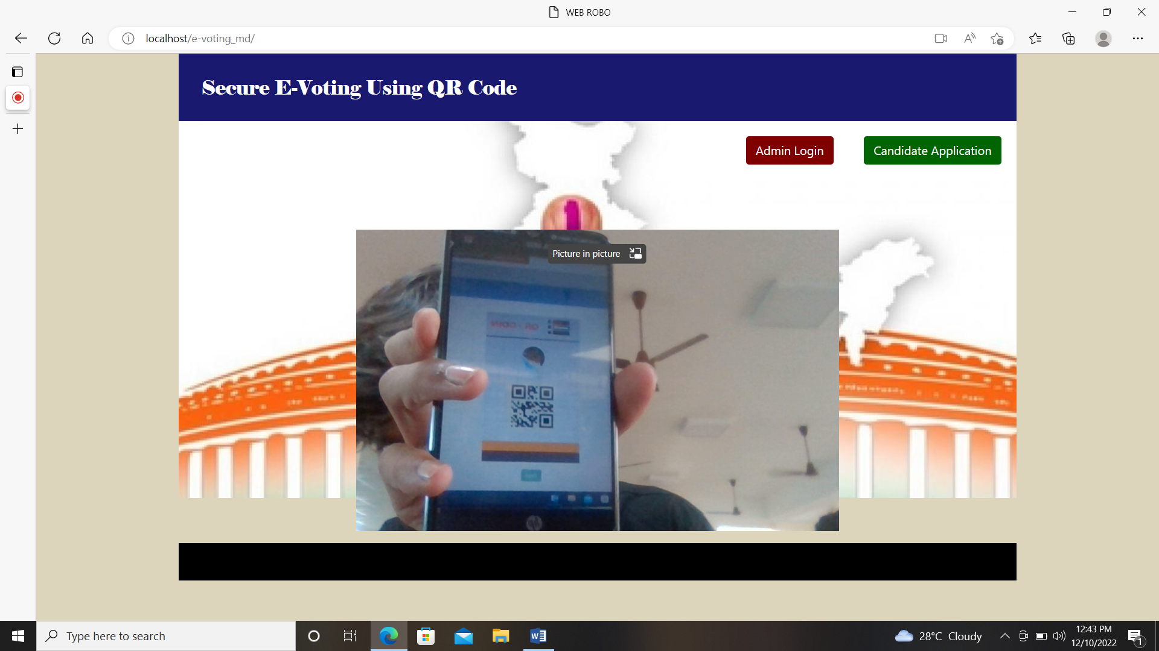

**Candidate application**

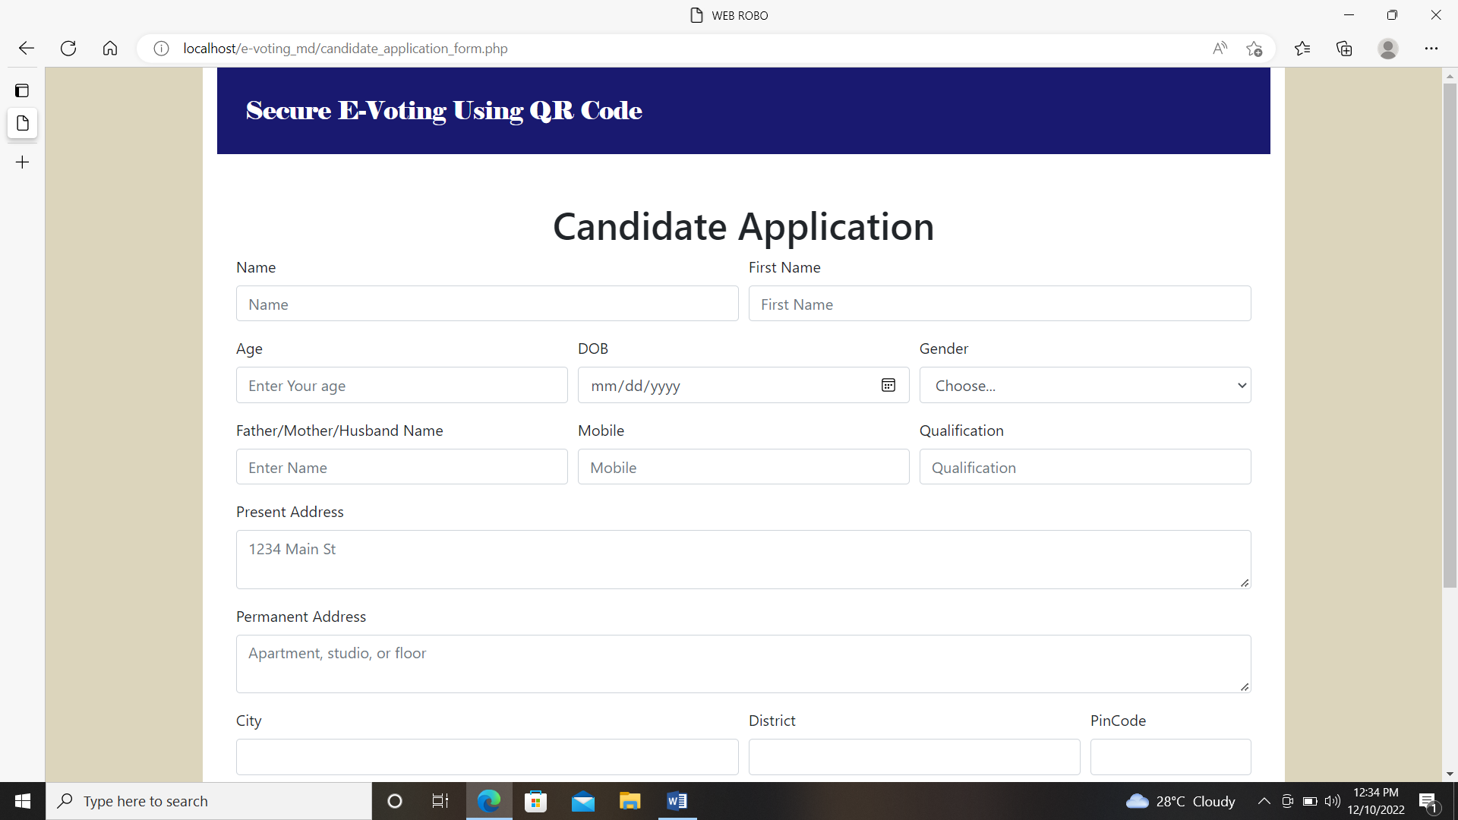

**Admin Login**

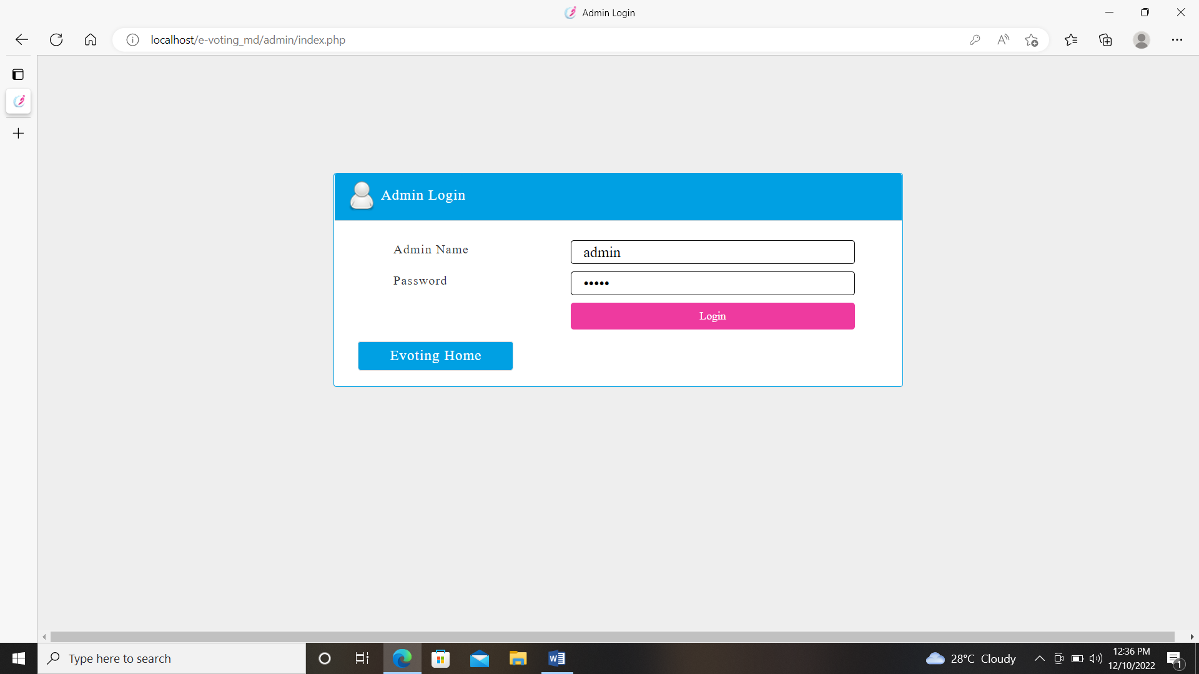

**View applied candidates**

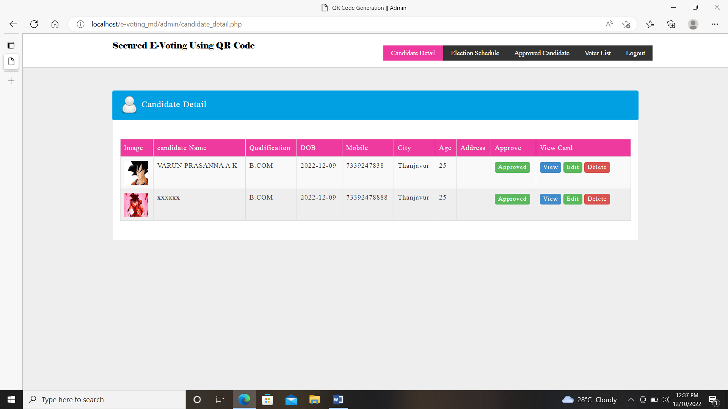

**Single view**

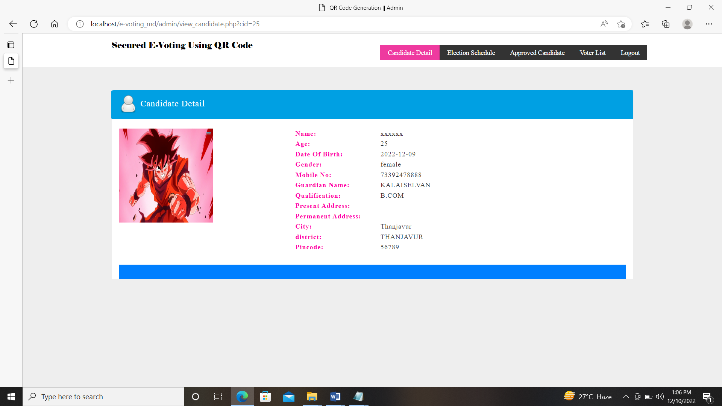

**Election schedule**

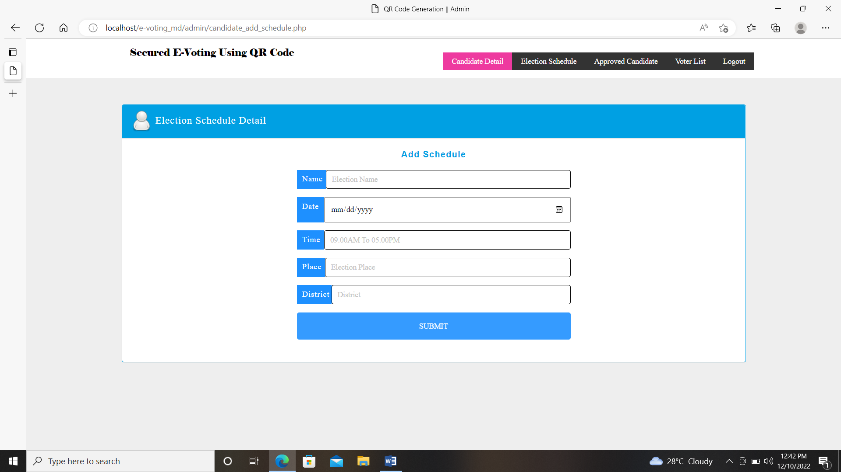

**View Election schedule**

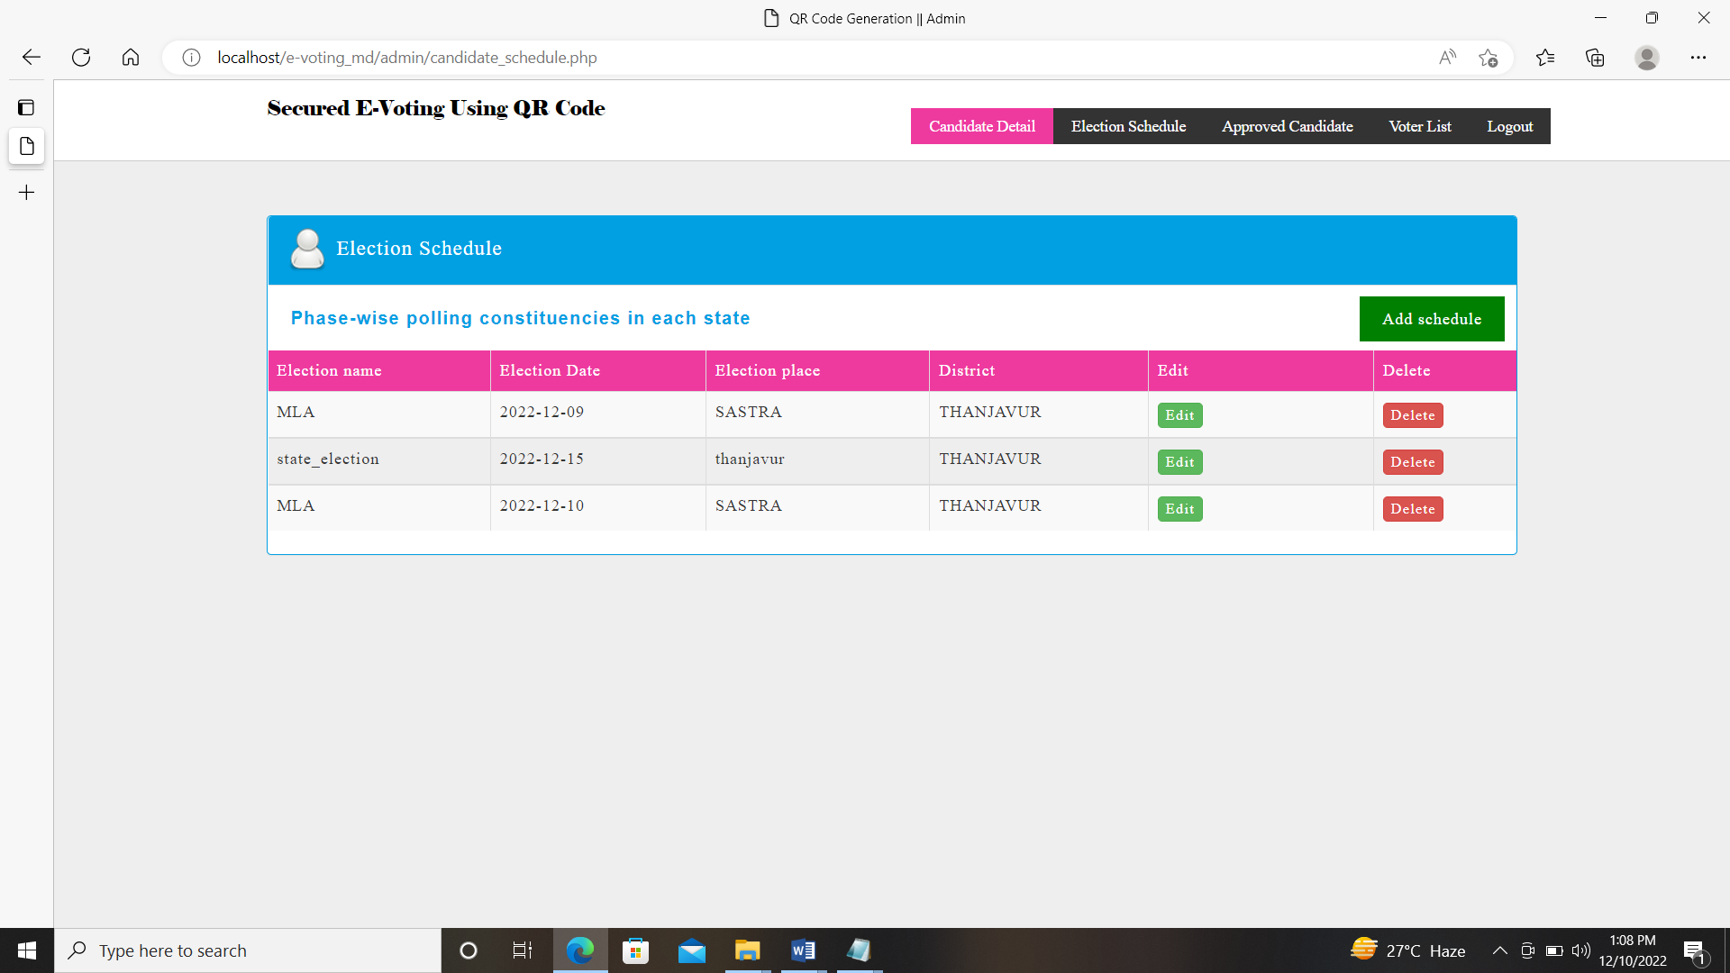

**Allocate party**

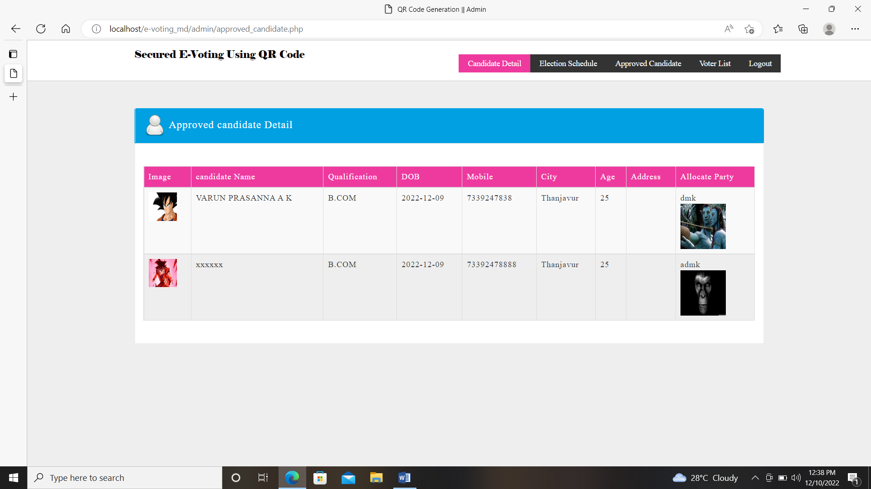

**Add Voters**

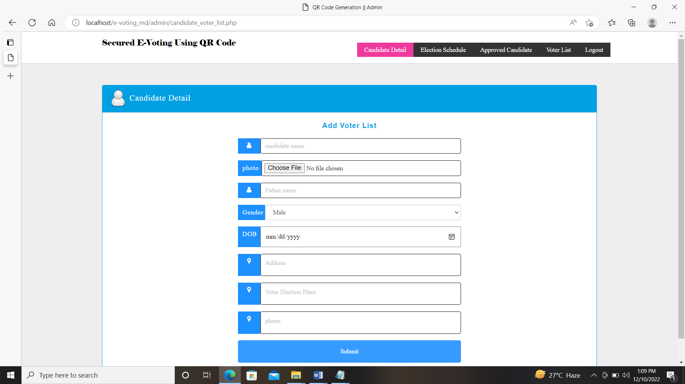

**View Voters**

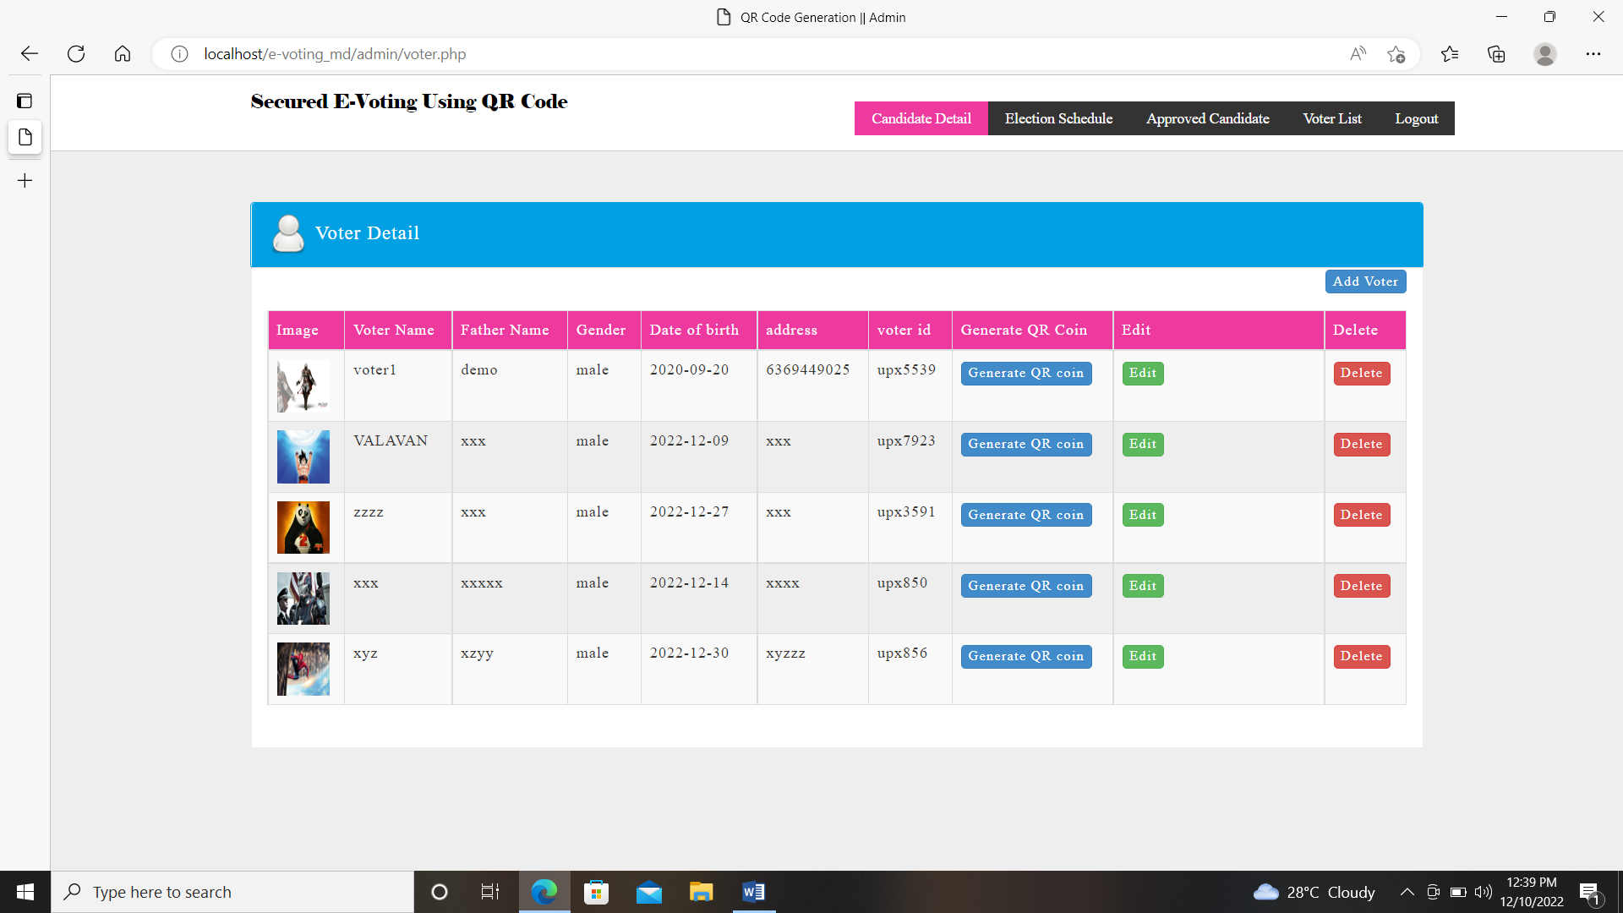

**Generate QR coin**

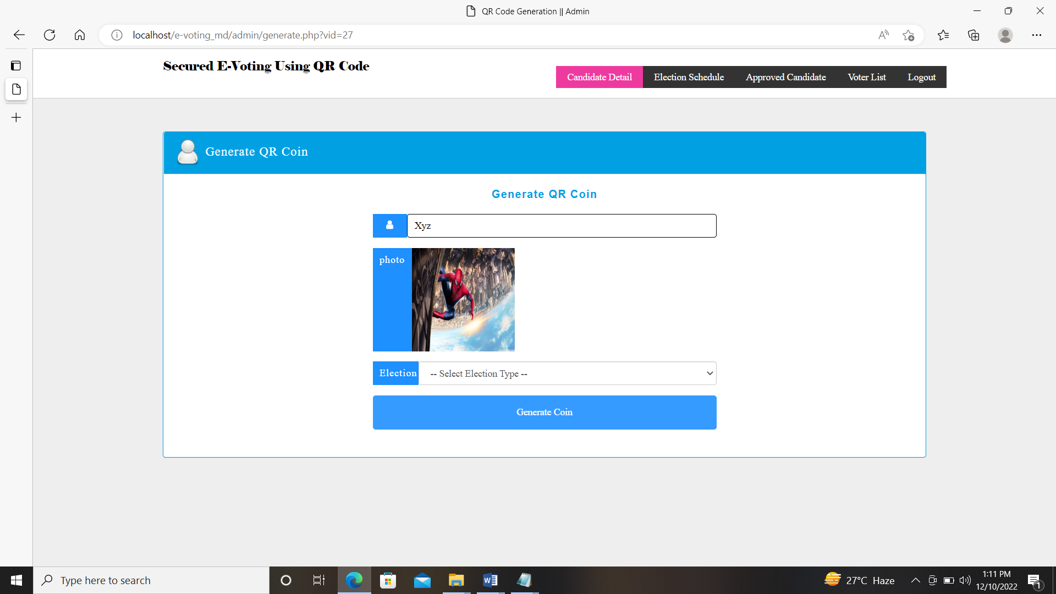

**View QR**

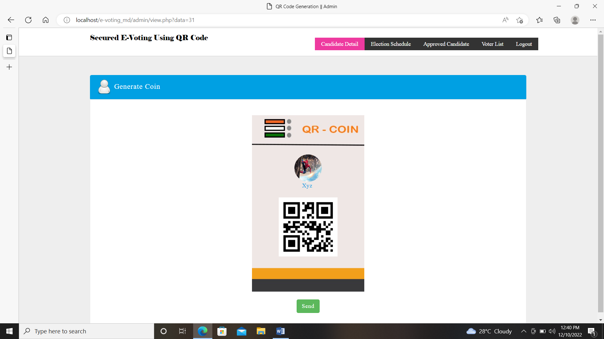

**View Candidates to vote**

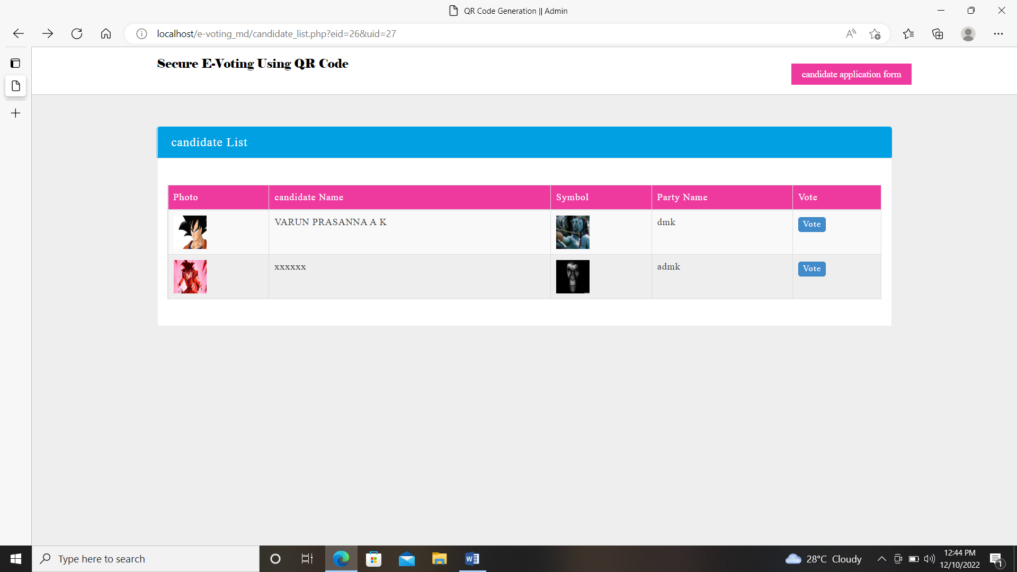

**Confirm vote**

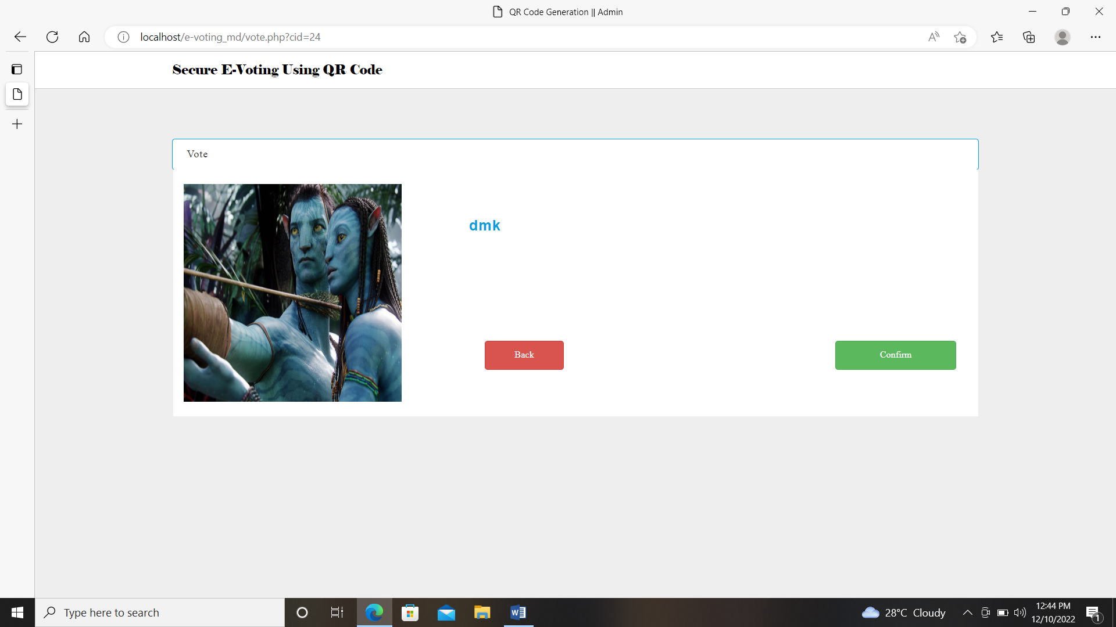

**encrypting vote**

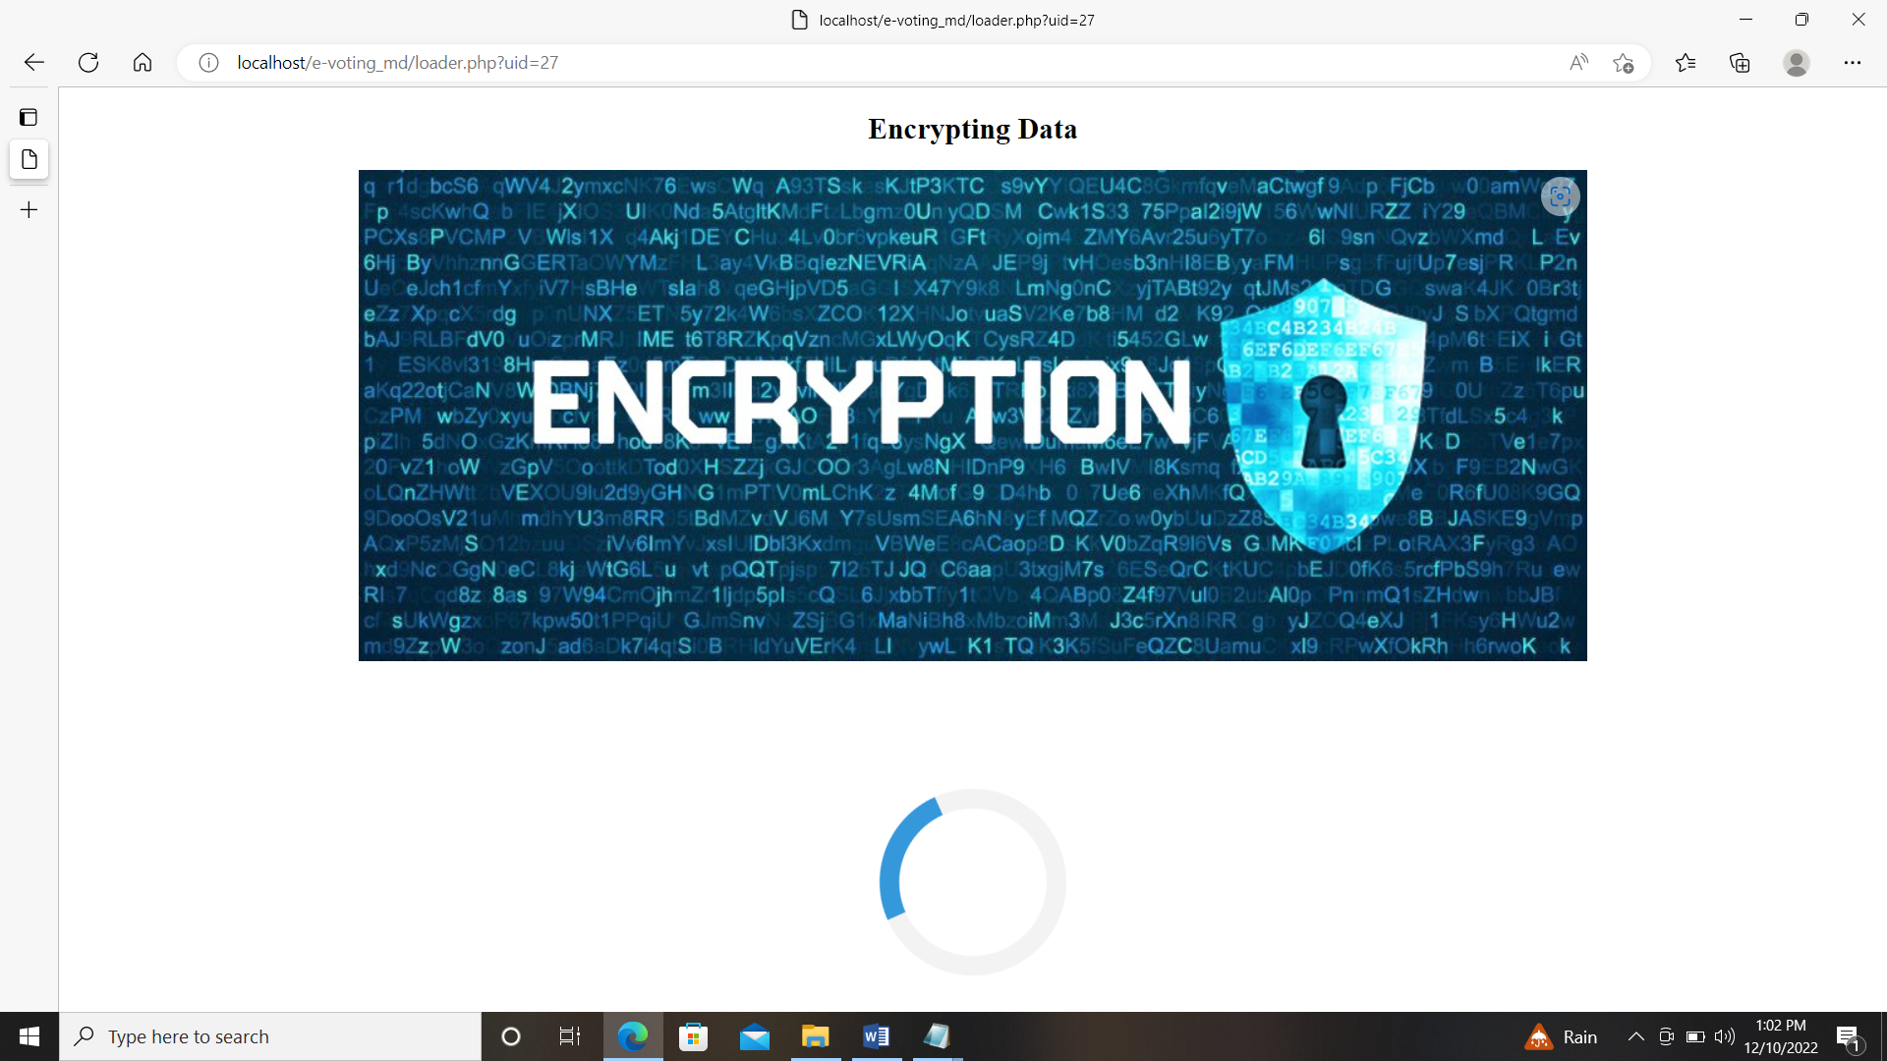

**Voted successfully**

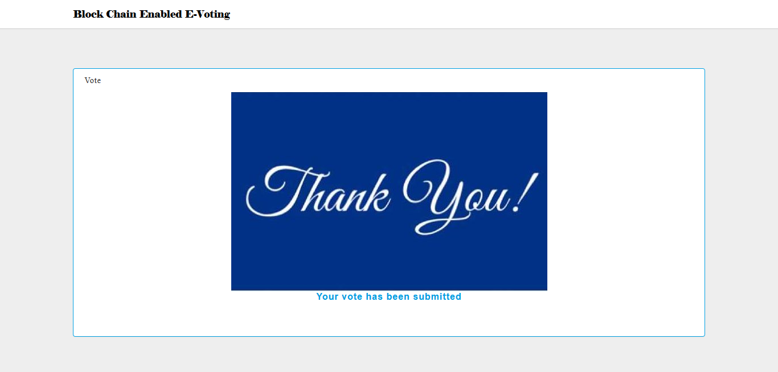

**Home page when no election schedule**

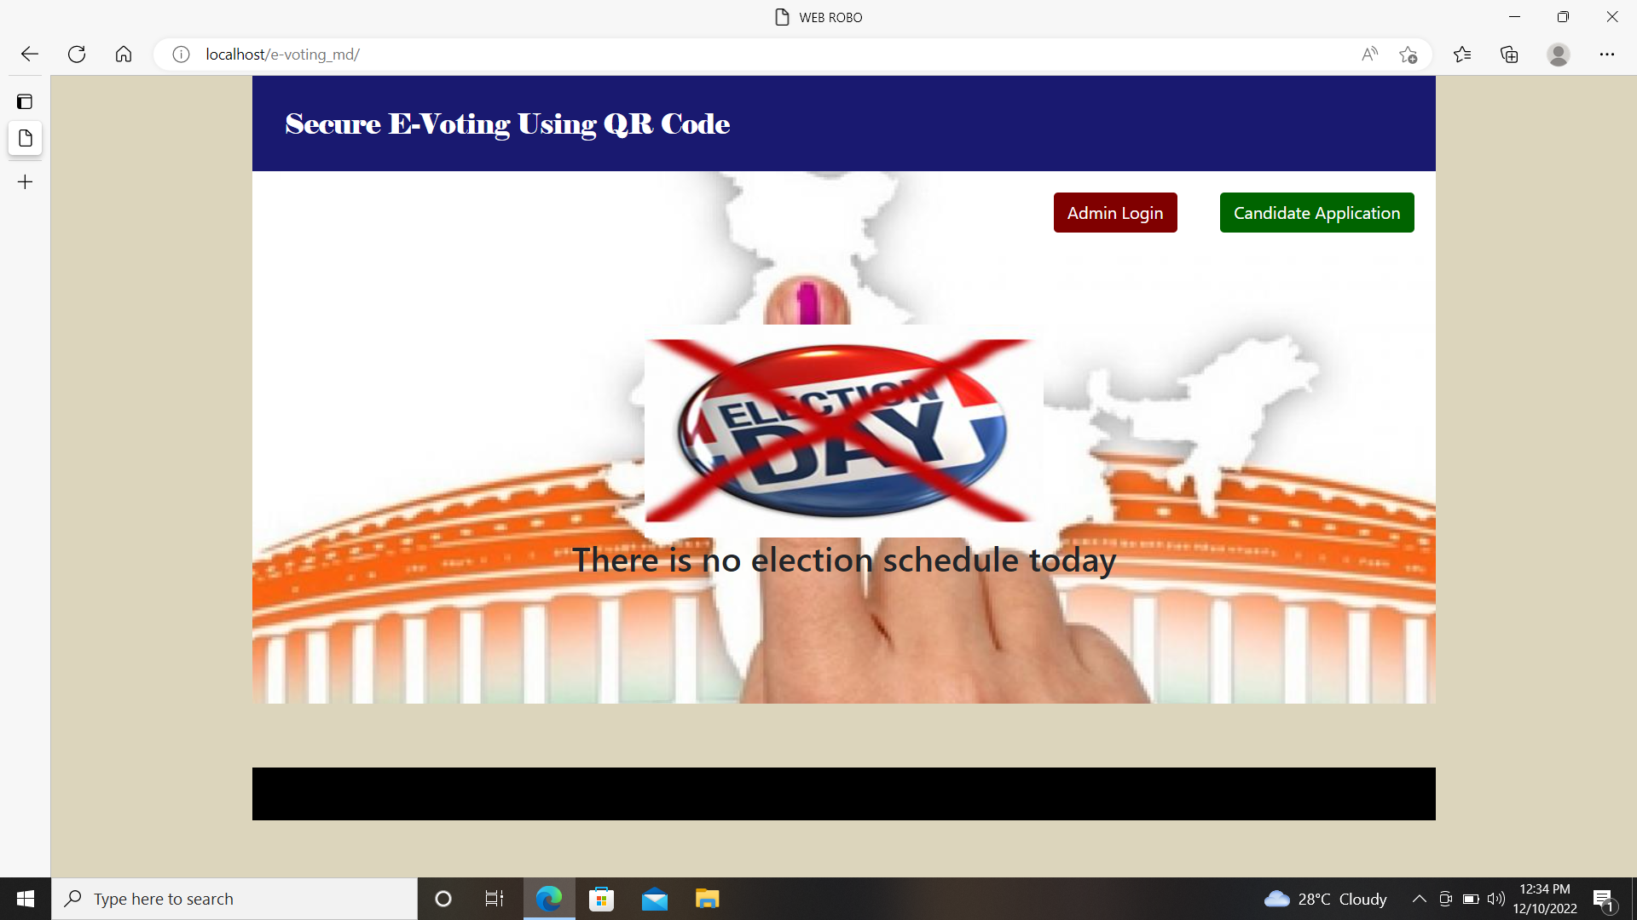

**Conclusion:**

E-Voting system is efficient adheres to voting protocol, simple & easy to maintain. It maintains details of voting, voters, candidate & election. It decreased false voting & it has increased voting percentage. Since E-Voting relates to the Internet, there is a possibility of more attackers. Another issue with E-voting is educating the voters. We cannot consider that all the users are having computer knowledge and they will use the E-voting systems easily. Designed E-Voting System must be easy to use. We should consider the fact that a large portion of the voting public has a very little knowledge about the computers. Voting through QR Coin Scanning has been implemented successfully. All votes has been implemented in encryption format. To avoid issues like hacking, we used block chain technology.

**BIBLIOGRAPHYBOOKS:**

* PHP 5 Fast and Easy Web Development (Fast & Easy Web Development) - Julie Meloni
* Web Database Applications with PHP and MySQL[Hugh E. Williams](http://www.amazon.co.uk/Hugh-E.-Williams/e/B001IGLN0Q/ref=ntt_athr_dp_pel_1)(Author),[David Lane](http://www.amazon.co.uk/David-Lane/e/B001IGFLCC/ref=ntt_athr_dp_pel_2)(Author)
* Professional Red hat Enterprise Linux 5 - Kapil sharma& Tony steidler-dennison

MySQL(TM): The Complete ReferenceVikram Vaswani(Author)

**WEBSITES:**

* <http://php.net/manual/en/book.mysql.php>
* [www.w3schools.com](http://www.w3schools.com/)
* <http://www.esponce.com/resources/about-qr-codes>